“Functional Models - Python-Based Java Runtime Behavior Analysis and Repair System”
Navya Sree Ausula, Systems Analyst
February 10, 2026

- Use Case Diagram
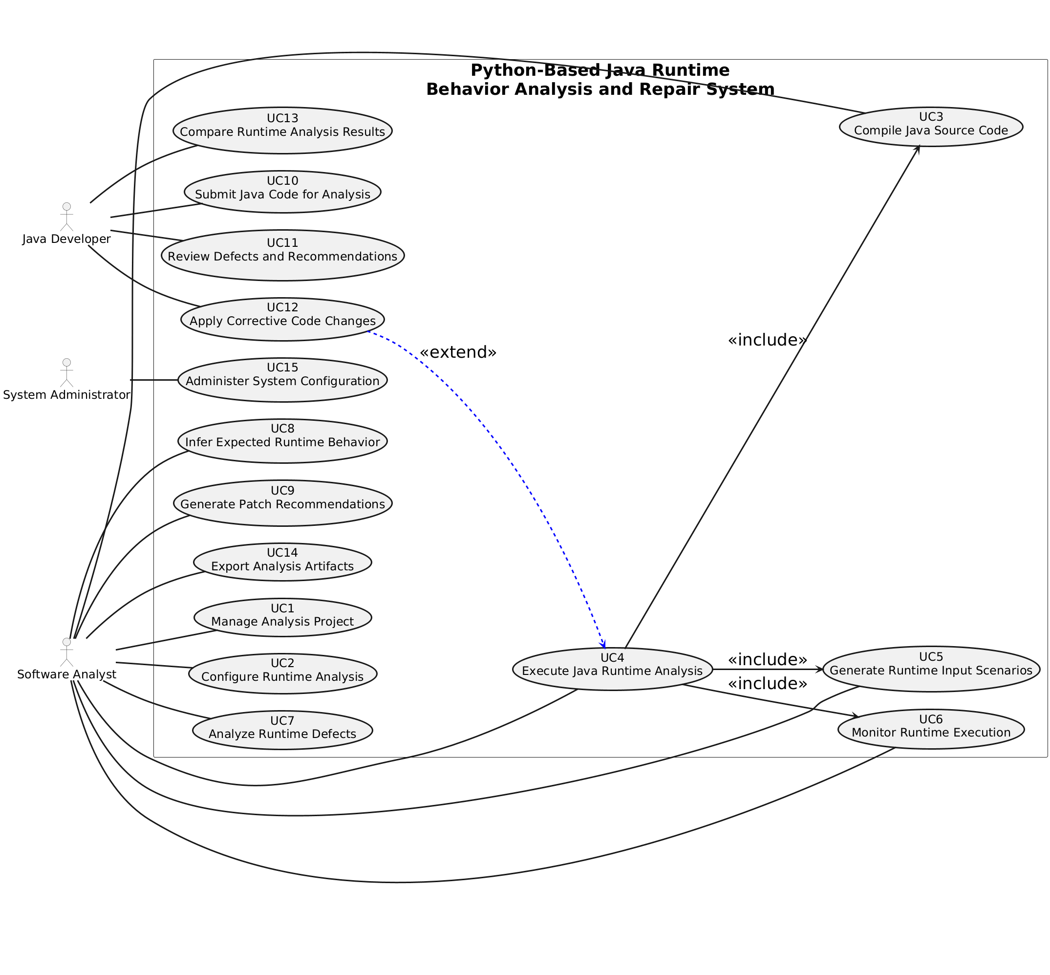
Diagram 1: Use Case Diagram for “Python-Based Java Runtime Behavior Analysis and Repair System”
- Use Case Description
Use Case - 1
Use Case Name: Manage Analysis Project |  | ID:UC1 | Importance Level: High
Primary Actor: Software Analyst | Use Case Type: System
Stakeholders and Interests: The Software Analyst requires the ability to create, store, retrieve, and manage runtime analysis projects to ensure that Java analysis activities are organized, repeatable, and traceable. The organization has an interest in maintaining consistent project configurations and preserving analysis results for auditing, comparison, and reuse purposes.
Brief Description: This use case allows the Software Analyst to create a new analysis project or manage an existing project by saving, loading, archiving, or restoring runtime analysis configurations and associated data.
Trigger: The Software Analyst selects the option to create a new analysis project or manage an existing analysis project.
Type: External
Relationships:
Association: Use Case 1 – Manage Analysis Project is associated with the Software Analyst actor.
Include: Use Case 2 – Configure Runtime Analysis.
Extend: None
Generalization: None
Normal Flow of Events:
- The Software Analyst initiates project management by selecting the create or manage project option.
- The system prompts the Software Analyst to enter or select project identification details.
- The system invokes Use Case 2 – Configure Runtime Analysis to define or update project settings.
- The system saves the project configuration and associated metadata.
- The system confirms successful project creation or update to the Software Analyst.
SubFlows:
S-1: If an existing project is selected, the system loads the stored project configuration and analysis context.
Alternate/Exceptional Flows:
A-1: If required project information is missing or invalid, the system displays an error message and requests correction.

This use case description is covering the requirements – FR-1, FR-19, FR-20, FR-36, FR-37

Use Case - 2
Use Case Name: Configure Runtime Analysis |  | ID:UC-2 | Importance Level: High
Primary Actor: Software Analyst | Use Case Type: System
Stakeholders and Interests: The Software Analyst requires the ability to define runtime analysis objectives, defect categories, and execution constraints to ensure meaningful and controlled analysis of Java programs. The organization has an interest in enforcing consistent runtime configurations to improve defect detection accuracy and system reliability.
Brief Description: This use case allows the Software Analyst to configure runtime analysis parameters including defect categories, execution limits, runtime boundaries, and monitoring options for a selected analysis project.
Trigger: The Software Analyst selects the option to configure runtime analysis for an analysis project.
Type: External
Relationships:
Association: Use Case 2 – Configure Runtime Analysis is associated with the Software Analyst actor.
Include: None
Extend: None
Generalization: None
Normal Flow of Events:
- The Software Analyst selects a project for which runtime analysis settings are to be configured.
- The system displays available runtime defect categories and execution configuration options.
- The Software Analyst selects defect categories and specifies execution limits and parameters.
- The system validates the provided configuration values.
- The system saves the runtime analysis configuration for the project.
SubFlows:
S-1: If previously saved configuration exists, the system loads and displays current runtime analysis settings.
Alternate/Exceptional Flows:
A-1: If invalid configuration values are provided, the system displays an error message and requests correction

This use case description is covering the requirements – FR-2, FR-5, FR-31, FR-32, FR-34, FR-35

Use Case - 3
Use Case Name: Compile Java Source Code |  | ID:UC-3 | Importance Level: High
Primary Actor: Software Analyst | Use Case Type: System
Stakeholders and Interests: The Software Analyst needs to compile Java source code under Python orchestration to ensure that the code can be executed safely and analyzed. The organization wants to guarantee that Java programs are syntactically correct and ready for controlled runtime analysis.
Brief Description: This use case allows the Software Analyst to initiate compilation of Java source files for a selected analysis project using the Python-based orchestration system.
Trigger: The Software Analyst selects the option to compile Java source code for an analysis project.
Type: External
Relationships:
Association: Use Case 3 – Compile Java Source Code is associated with the Software Analyst actor.
Include: None
Extend: None
Generalization: None
Normal Flow of Events:
- The Software Analyst selects the analysis project to compile.
- The system verifies the existence and integrity of Java source files.
- The system initiates compilation of Java source code using Python orchestration.
- The system monitors compilation and reports success or failure to the Software Analyst.
- The system stores compilation results for subsequent runtime analysis.
SubFlows:
S-1: If missing or corrupted source files are detected, the system prompts the Software Analyst to correct or provide files.
Alternate/Exceptional Flows:
A-1: If compilation fails due to syntax errors or other issues, the system displays error messages and highlights affected files.

This use case description is covering the requirements – FR-3

Use Case - 4
Use Case Name: Execute Java Runtime Analysis |  | ID:UC-4 | Importance Level: High
Primary Actor: Software Analyst | Use Case Type: System
Stakeholders and Interests: The Software Analyst requires the ability to execute Java programs under controlled runtime scenarios to detect defects and monitor behavior. The organization wants to ensure that runtime defects, execution traces, and crashes are captured for accurate analysis and patch generation.
Brief Description: This use case allows the Software Analyst to run compiled Java programs using Python orchestration while monitoring execution, applying inputs, and capturing exceptions and execution paths.
Trigger: The Software Analyst selects the option to execute runtime analysis for a project.
Type: External
Relationships:
Association: Use Case 4 – Execute Java Runtime Analysis is associated with the Software Analyst actor.
Include: Use Case 3 – Compile Java Source Code, Use Case 5 – Generate Runtime Input Scenarios, Use Case 6 – Monitor Runtime Execution.
Extend: None
Generalization: None
Normal Flow of Events:
- The Software Analyst selects the project to execute runtime analysis.
- The system verifies compilation status (via Use Case 3 – Compile Java Source Code).
- The system generates input scenarios as needed (via Use Case 5 – Generate Runtime Input Scenarios).
- The system executes Java programs under controlled conditions and monitors execution (via Use Case 6 – Monitor Runtime Execution).
- The system logs execution details and reports outcomes to the Software Analyst.
SubFlows:
S-1: If execution time or memory limits are reached, the system halts execution and reports the condition.
Alternate/Exceptional Flows:
A-1: If runtime exceptions occur, the system captures them and notifies the Software Analyst for review.

This use case description is covering the requirements – FR-4, FR-8

Use Case - 5
Use Case Name: Generate Runtime Input Scenarios |  | ID:UC-5 | Importance Level: High
Primary Actor: Software Analyst | Use Case Type: System
Stakeholders and Interests: The Software Analyst requires the ability to generate randomized and boundary-value inputs to explore Java program execution paths. The organization wants to ensure that runtime defects are exposed and analysis is thorough without manually writing exhaustive test cases.
Brief Description: This use case allows the Software Analyst to generate input data, including randomized and boundary-value inputs, to drive Java runtime analysis.
Trigger: The Software Analyst selects the option to generate runtime input scenarios for a project.
Type: External
Relationships:
Association: Use Case 5 – Generate Runtime Input Scenarios is associated with the Software Analyst actor.
Include: None
Extend: None
Generalization: None
Normal Flow of Events:
- The Software Analyst selects a project for which inputs are to be generated.
- The system provides options for randomized or boundary-value input generation.
- The Software Analyst selects the desired input generation mode.
- The system generates input scenarios and stores them for runtime execution.
- The system confirms that input scenarios are ready for use in execution.
SubFlows:
S-1: If previously generated input scenarios exist, the system offers to reuse or overwrite them.
Alternate/Exceptional Flows:
A-1: If input generation fails due to invalid configuration, the system displays an error and requests correction.

This use case description is covering the requirements – FR-6, FR-7

Use Case - 6
Use Case Name: Monitor Runtime Execution |  | ID:UC-6 | Importance Level: High
Primary Actor: Software Analyst | Use Case Type: System
Stakeholders and Interests: The Software Analyst requires the ability to capture execution traces, exceptions, crashes, and execution paths during Java runtime analysis. The organization wants to ensure that all runtime behavior is logged accurately to support defect analysis, patch generation, and system auditing.
Brief Description: This use case allows the Software Analyst to monitor Java program execution in real time, capturing runtime data for further analysis.
Trigger: The Software Analyst initiates execution monitoring during runtime analysis.
Type: External
Relationships:
Association: Use Case 6 – Monitor Runtime Execution is associated with the Software Analyst actor.
Include: None
Extend: None
Generalization: None
Normal Flow of Events:
- The system begins monitoring execution when runtime analysis starts.
- The system records method calls, execution paths, and runtime exceptions.
- The system logs all crashes or abnormal behavior detected during execution.
- The system presents execution summaries to the Software Analyst.
- The system stores monitoring data for subsequent defect analysis.
SubFlows:
S-1: If system resources become constrained during monitoring, the system throttles data collection and notifies the Software Analyst.
Alternate/Exceptional Flows:
A-1: If runtime monitoring fails, the system displays an error message and logs partial execution data.

This use case description is covering the requirements – FR-9, FR-10, FR-11, FR-38

Use Case - 7
Use Case Name: Analyze Runtime Defects |  | ID:UC-7 | Importance Level: High
Primary Actor: Software Analyst | Use Case Type: System
Stakeholders and Interests: The Software Analyst requires the ability to inspect, classify, approve, and assign severity levels to detected runtime defects. The organization wants to ensure that all defects are accurately evaluated to improve Java program reliability and guide corrective actions.
Brief Description: This use case allows the Software Analyst to analyze captured runtime defects, classify their severity, approve valid findings, and prepare them for corrective recommendation generation.
Trigger: The Software Analyst selects the option to analyze runtime defects after execution monitoring.
Type: External
Relationships:
Association: Use Case 7 – Analyze Runtime Defects is associated with the Software Analyst actor.
Include: None
Extend: None
Generalization: None
Normal Flow of Events:
- The Software Analyst accesses runtime defect reports generated during execution.
- The system displays defect details including type, severity, and execution context.
- The Software Analyst classifies defects by severity and approves or rejects them.
- The system stores the approved defects for corrective recommendation generation.
- The system confirms analysis completion to the Software Analyst.
SubFlows:
S-1: If additional defect data is required, the Software Analyst can request re-execution of specific runtime scenarios.
Alternate/Exceptional Flows:
A-1: If defect classification is inconsistent or incomplete, the system prompts the Software Analyst to provide missing information.

This use case description is covering the requirements – FR-12, FR-13

Use Case - 8
Use Case Name: Infer Expected Runtime Behavior |  | ID:UC-8 | Importance Level: High
Primary Actor: Software Analyst | Use Case Type: System
Stakeholders and Interests: The Software Analyst requires the ability to infer expected behavior of Java programs based on observed execution outcomes. The organization wants to ensure that detected defects are understood in context and that corrective actions target true runtime anomalies.
Brief Description: This use case allows the Software Analyst to request the system to infer expected runtime behavior from execution results and detected defects.
Trigger: The Software Analyst selects the option to infer expected runtime behavior after analyzing runtime defects.
Type: External
Relationships:
Association: Use Case 8 – Infer Expected Runtime Behavior is associated with the Software Analyst actor.
Include: None
Extend: None
Generalization: None
Normal Flow of Events:
- The Software Analyst selects defects or execution traces for behavior inference.
- The system analyzes execution patterns and defect occurrences.
- The system generates expected behavior models or predictions for the selected code paths.
- The system presents inferred runtime behavior to the Software Analyst.
- The system stores inferred behavior models for future analysis or corrective recommendations.
SubFlows:
S-1: If conflicting or incomplete execution data exists, the system requests additional runtime analysis.
Alternate/Exceptional Flows:
A-1: If behavior inference cannot be completed due to insufficient data, the system notifies the Software Analyst and suggests re-execution of runtime scenarios.

This use case description is covering the requirements – FR-14

Use Case - 9
Use Case Name: Generate Patch Recommendations |  | ID:UC-9 | Importance Level: High
Primary Actor: Software Analyst | Use Case Type: System
Stakeholders and Interests: The Software Analyst requires the ability to generate Java corrective code suggestions for approved runtime defects. The organization wants to ensure that runtime issues are addressed efficiently and consistently, reducing the risk of repeated failures.
Brief Description: This use case allows the Software Analyst to request the system to produce corrective patch recommendations for identified and approved runtime defects.
Trigger: The Software Analyst selects the option to generate patch recommendations after analyzing runtime defects and inferring expected behavior.
Type: External
Relationships:
Association: Use Case 9 – Generate Patch Recommendations is associated with the Software Analyst actor.
Include: None
Extend: None
Generalization: None
Normal Flow of Events:
- The Software Analyst selects approved runtime defects for which patches are needed.
- The system analyzes defect data, inferred behavior, and execution context.
- The system generates suggested Java code changes to correct the defects.
- The system presents patch recommendations to the Software Analyst.
- The system stores the recommendations for review and potential application.
SubFlows:
S-1: If multiple patch options are possible, the system ranks suggestions based on likelihood of correctness and minimal disruption.
Alternate/Exceptional Flows:
A-1: If patch generation fails due to incomplete or conflicting defect data, the system notifies the Software Analyst and suggests additional analysis.

This use case description is covering the requirements – FR-15, FR-16

Use Case - 10
Use Case Name: Submit Java Code for Analysis |  | ID:UC-10 | Importance Level: High
Primary Actor: Java Developer | Use Case Type: System
Stakeholders and Interests: The Java Developer requires the ability to submit Java source files and select classes or methods for runtime analysis. The organization wants to ensure that developers can provide code for automated defect detection and analysis without errors or omissions.
Brief Description: This use case allows the Java Developer to submit Java source code and specify targeted classes or methods for runtime behavior analysis.
Trigger: The Java Developer selects the option to submit Java code for analysis.
Type: External
Relationships:
Association: Use Case 10 – Submit Java Code for Analysis is associated with the Java Developer actor.
Include: None
Extend: None
Generalization: None
Normal Flow of Events:
- The Java Developer selects source files for submission.
- The system validates the files for correctness and completeness.
- The Java Developer specifies classes or methods for targeted analysis.
- The system confirms submission and stores the code for execution and monitoring.
- The system notifies the Java Developer that the code is ready for runtime analysis.
SubFlows:
S-1: If previously submitted code exists for the project, the system prompts the developer to overwrite or version the code.
Alternate/Exceptional Flows:
A-1: If submitted files are invalid or incomplete, the system displays errors and requests correction from the Java Developer.

This use case description is covering the requirements – FR-21, FR-22

Use Case - 11
Use Case Name: Review Defects and Recommendations |  | ID:UC-11 | Importance Level: High
Primary Actor: Java Developer | Use Case Type: System
Stakeholders and Interests: The Java Developer requires the ability to review detected runtime defects and system-generated patch recommendations. The organization wants to ensure that developers can verify the correctness of defects and proposed corrections before applying changes.
Brief Description: This use case allows the Java Developer to inspect runtime defects identified by the system and review suggested corrective code patches.
Trigger: The Java Developer selects the option to review defects and patch recommendations after runtime analysis.
Type: External
Relationships:
Association: Use Case 11 – Review Defects and Recommendations is associated with the Java Developer actor.
Include: None
Extend: None
Generalization: None
Normal Flow of Events:
- The Java Developer accesses defect reports and associated recommendations.
- The system displays details for each defect, including type, severity, and execution context.
- The Java Developer evaluates each recommended patch for correctness and applicability.
- The system logs the review actions for auditing purposes.
- The system confirms that the review is complete and stores results for subsequent corrective actions.
SubFlows:
S-1: If additional clarification is needed for a defect, the developer may request more execution data from the system.
Alternate/Exceptional Flows:
A-1: If a recommendation cannot be applied due to conflicts or invalid code, the system notifies the Java Developer and suggests alternatives.

This use case description is covering the requirements – FR-23, FR-24, FR-25, FR-26, FR-28, FR-29

Use Case – 12
Use Case Name: Apply Corrective Code Changes |  | ID:UC-12 | Importance Level: High
Primary Actor: Java Developer | Use Case Type: System
Stakeholders and Interests: The Java Developer requires the ability to apply approved patch recommendations to Java source code. The organization wants to ensure that runtime defects are corrected effectively and that subsequent executions reflect these changes.
Brief Description: This use case allows the Java Developer to implement system-generated or manually approved corrective code changes to resolve detected runtime defects.
Trigger: The Java Developer selects the option to apply corrective code changes after reviewing defects and recommendations.
Type: External
Relationships:
Association: Use Case 12 – Apply Corrective Code Changes is associated with the Java Developer actor.
Include: None
Extend: Use Case 4 – Execute Java Runtime Analysis.
Generalization: None
Normal Flow of Events:
- The Java Developer selects approved patch recommendations to apply.
- The system applies changes to the Java source code.
- The Java Developer reviews applied changes and confirms correctness.
- The system logs changes and updates the project repository.
- The system confirms that corrective actions are complete and ready for re-execution.
SubFlows:
S-1: If conflicts occur during code application, the system prompts the developer to resolve them before proceeding.
Alternate/Exceptional Flows:
A-1: If patch application fails due to code incompatibility, the system notifies the Java Developer and suggests manual correction.

This use case description is covering the requirements – FR-25, FR-26, FR-30

Use Case - 13
Use Case Name: Compare Runtime Analysis Results |  | ID:UC-13 | Importance Level: Medium
Primary Actor: Java Developer | Use Case Type: System
Stakeholders and Interests: The Java Developer requires the ability to compare execution behavior before and after applying corrective code changes. The organization wants to ensure that applied patches effectively resolve runtime defects and do not introduce new issues.
Brief Description: This use case allows the Java Developer to compare runtime execution results from previous and current analysis runs to verify the effectiveness of corrective code changes.
Trigger: The Java Developer selects the option to compare runtime analysis results after corrective changes are applied.
Type: External
Relationships:
Association: Use Case 13 – Compare Runtime Analysis Results is associated with the Java Developer actor.
Include: None
Extend: None
Generalization: None
Normal Flow of Events:
- The Java Developer selects the execution results to compare (pre- and post-patch).
- The system retrieves and displays execution traces, outputs, and defect occurrences.
- The Java Developer evaluates differences and identifies resolved or new issues.
- The system stores comparison results for recordkeeping.
- The system confirms that the comparison process is complete.
SubFlows:
S-1: If multiple executions exist, the system allows the developer to select which runs to compare.
Alternate/Exceptional Flows:
A-1: If results are missing or incomplete, the system notifies the Java Developer and requests additional runtime analysis.

This use case description is covering the requirements – FR-16, FR-27

Use Case - 14
Use Case Name: Export Analysis Artifacts |  | ID:UC-14 | Importance Level: Medium
Primary Actor: Software Analyst | Use Case Type: System
Stakeholders and Interests: The Software Analyst requires the ability to export defect reports, execution logs, and corrected Java source code. The organization wants to ensure that analysis artifacts are preserved, shared, and used for audits, documentation, or further development.
Brief Description: This use case allows the Software Analyst to export runtime analysis results and corrected source code for reporting or archival purposes.
Trigger: The Software Analyst selects the option to export analysis artifacts after completing runtime analysis and corrective actions.
Type: External
Relationships:
Association: Use Case 14 – Export Analysis Artifacts is associated with the Software Analyst actor.
Include: None
Extend: None
Generalization: None
Normal Flow of Events:
- The Software Analyst selects the types of artifacts to export (reports, logs, corrected code).
- The system generates the selected artifacts in the specified formats.
- The system allows the Software Analyst to choose export locations or file destinations.
- The system exports the artifacts and confirms completion.
- The system logs the export actions for auditing purposes.
SubFlows:
S-1: If the selected artifact format is incompatible, the system prompts the Software Analyst to choose an alternate format.
Alternate/Exceptional Flows:
A-1: If export fails due to storage or permission issues, the system notifies the Software Analyst and requests a valid destination.

This use case description is covering the requirements – FR-17, FR-18, FR-30, FR-40

Use Case - 15
Use Case Name: Administer System Configuration |  | ID:UC-15 | Importance Level: High
Primary Actor: System Administrator | Use Case Type: System
Stakeholders and Interests: The System Administrator requires the ability to manage users, roles, runtime environments, execution limits, logging levels, and monitor system resources. The organization wants to ensure secure, reliable, and properly configured runtime analysis operations.
Brief Description: This use case allows the System Administrator to configure system settings, manage user permissions, monitor performance, and ensure safe execution of Java runtime analysis.
Trigger: The System Administrator selects the option to administer system configuration.
Type: External
Relationships:
Association: Use Case 15 – Administer System Configuration is associated with the System Administrator actor.
Include: None
Extend: None
Generalization: None
Normal Flow of Events:
- The System Administrator logs in and accesses system configuration options.
- The administrator manages user accounts and role permissions.
- The administrator configures Java runtime versions, execution limits, and logging levels.
- The administrator monitors system resource usage during runtime analysis.
- The system saves all configuration changes and confirms completion.
SubFlows:
S-1: If a configuration conflict is detected, the system prompts the administrator to resolve it before saving changes.
Alternate/Exceptional Flows:
A-1: If unauthorized access is attempted, the system denies changes and logs the security event.

This use case description is covering the requirements – FR-31, FR-32, FR-33, FR-34, FR-35, FR-38, FR-39, FR-40

2. Activity Diagram
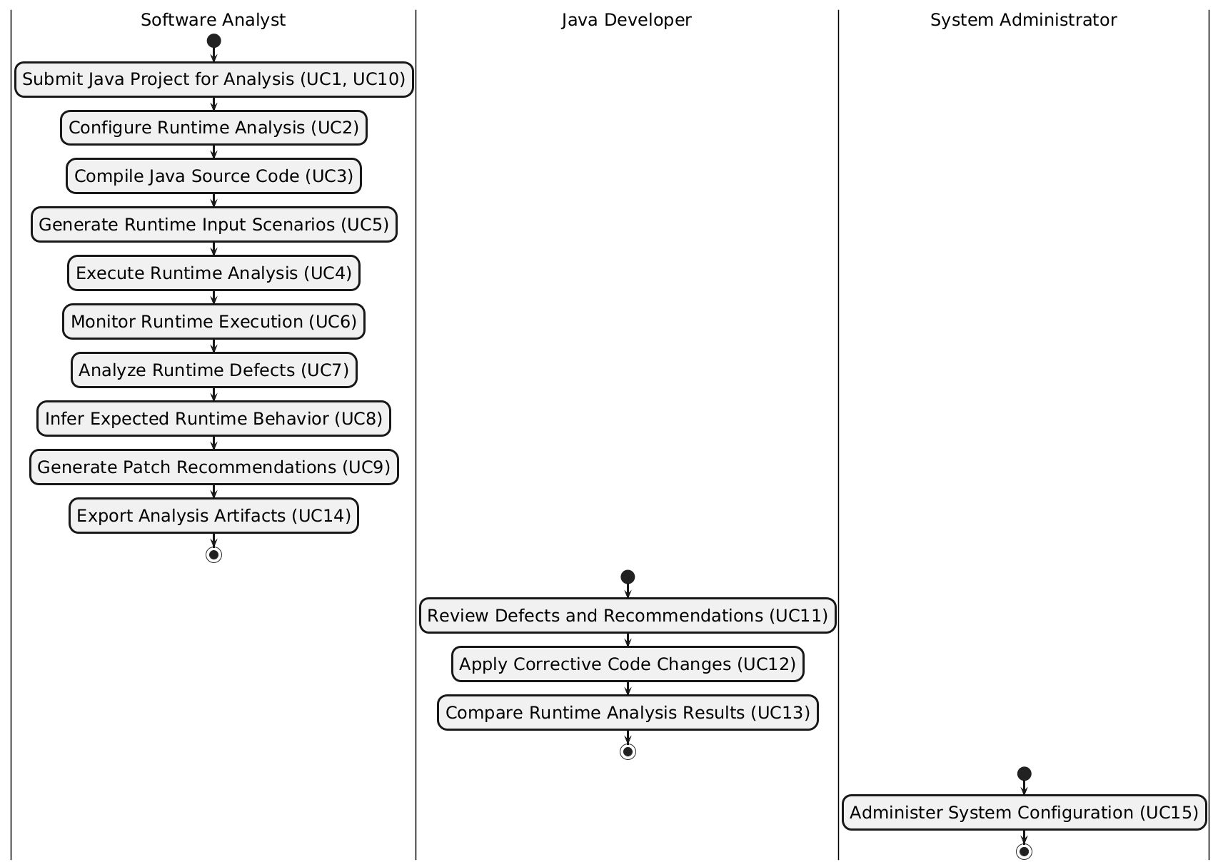
Diagram 2: Activity Diagram for “Python-Based Java Runtime Behavior Analysis and Repair System”

